Reading Week 9, Days 1-5
Compare and Contrast story themes, settings, and plots.
Standard: RL. 3.9 - I can compare and contrast themes, settings, and plots of two stories.
DAY 1
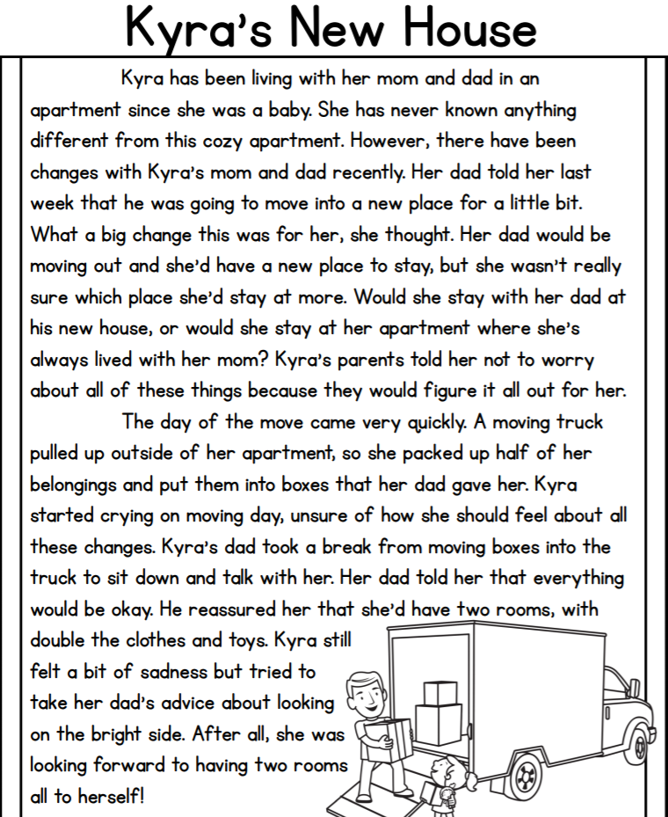
Read both passages. Then, answer the questions to compare and contrast the story themes.
Passage 1:

Question 1: What is the theme of passage 1?

Passage 2:
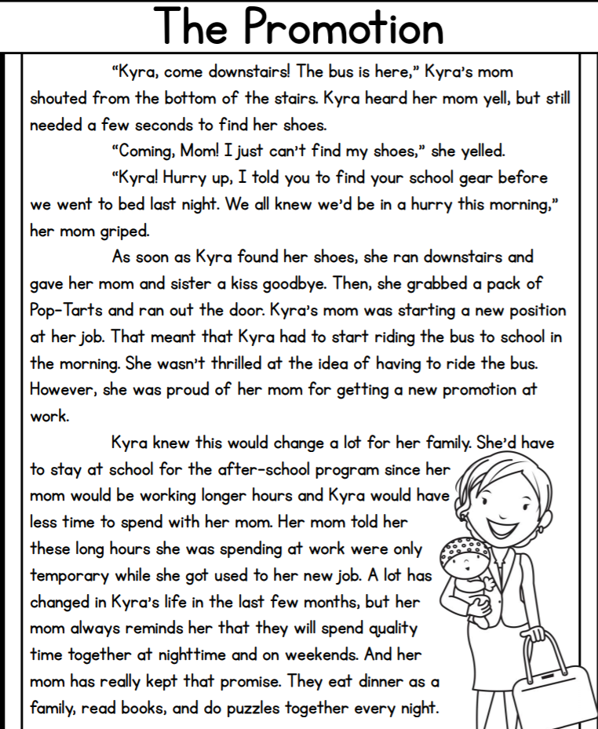

Question 2: What is the theme of passage 2?

Question 3: Compare - How are the themes of Kyra's New House and The Promotion the same?

Question 4: Contrast - How are the themes of Kyra's New House and The Promotion different?

DAY 2
Read both passages. Then, answer the questions to compare and contrast the story settings.
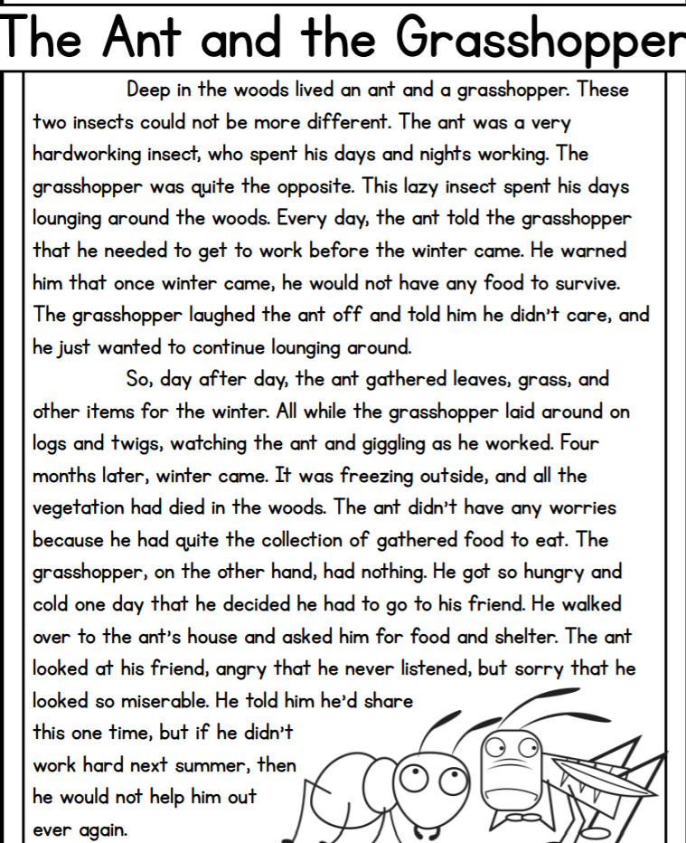
Passage 1:

Question 1: What is the setting of passage 1?

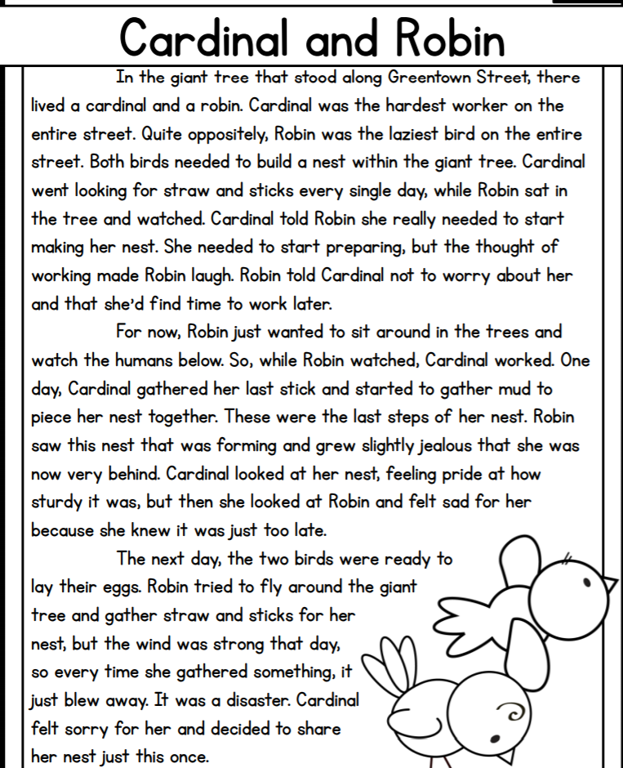
Passage 2:

Question 2: What is the setting of passage 2?

Question 3: Compare - How are the settings of The Ant & the Grasshopper and Cardinal & Robin the same?

Question 4: Contrast - How are the settings of The Ant & the Grasshopper and Cardinal & Robin different?

DAY 3
Read both passages. Then, answer the questions to compare and contrast the story plots.
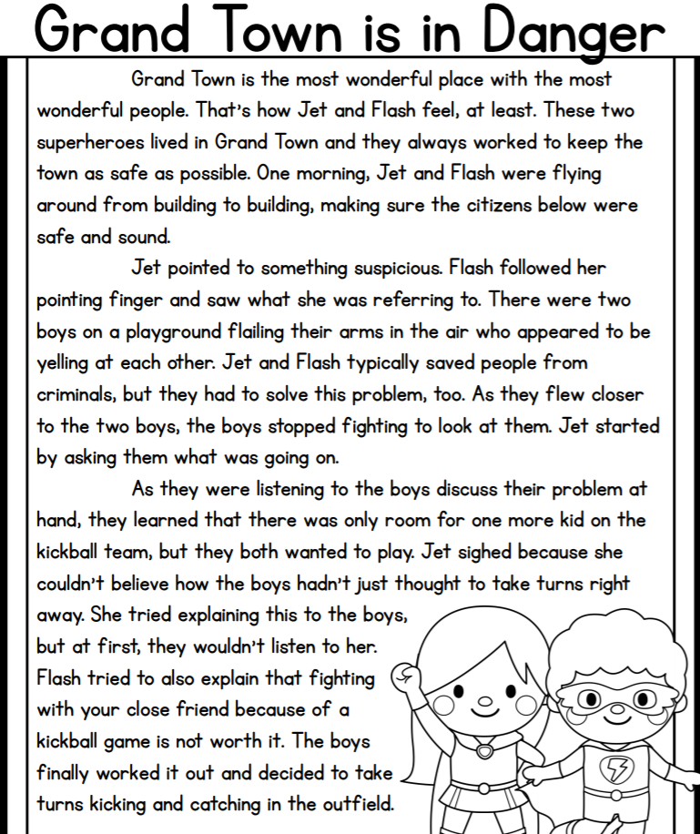
Passage 1:

Question 1: What is the plot of passage 1?

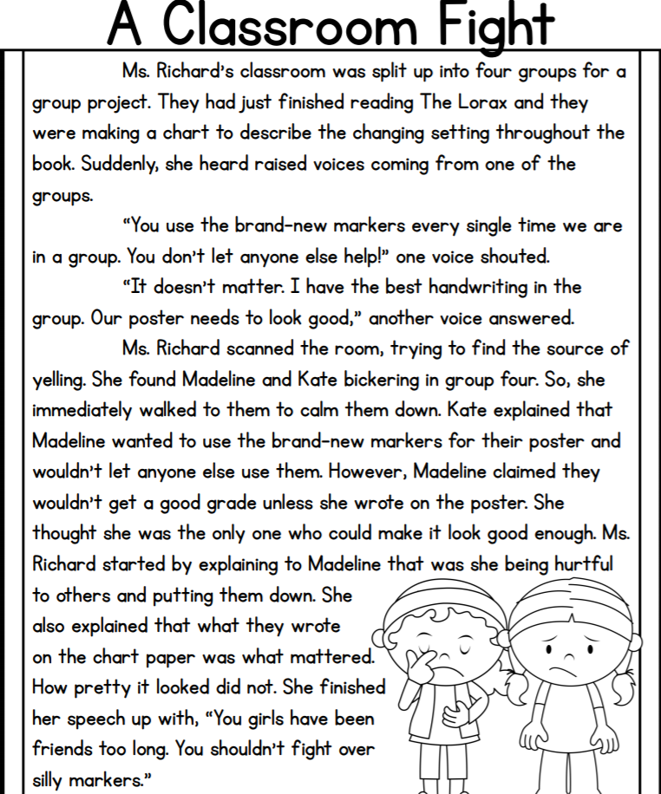
Passage 2:

Question 2: What is the plot of passage 2?

Question 3: Compare - How are the plots of Grand Town is in Danger and A Classroom Fight the same?

Question 4: Contrast - How are the plots of Grand Town is in Danger and A Classroom Fight different?

DAY 4
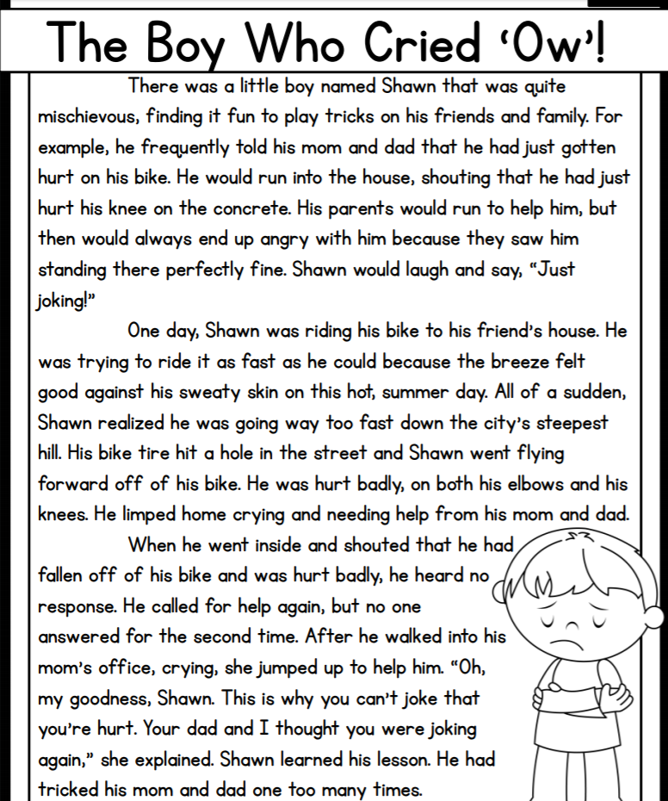
Read both passages. Then, answer the questions to compare and contrast the story themes, settings, and plots.
Passage 1:

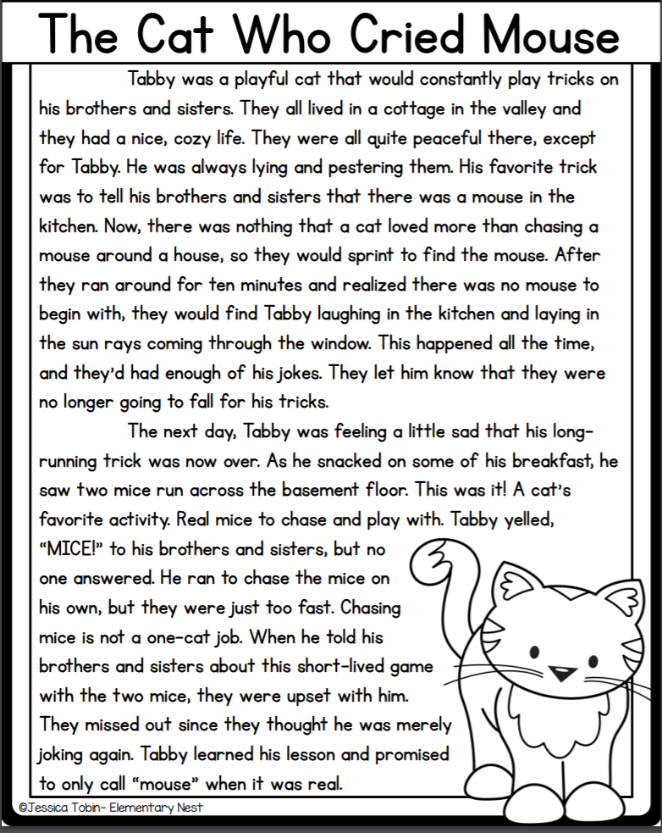
Passage 2:

Question 1: Themes - How are they the same? How are they different?

Question 2: Settings - How are they the same? How are they different?

Question 3: Plots - How are they the same? How are they different?

DAY 5
Read both passages. Then, answer the questions to compare and contrast the story themes, settings, and plots.
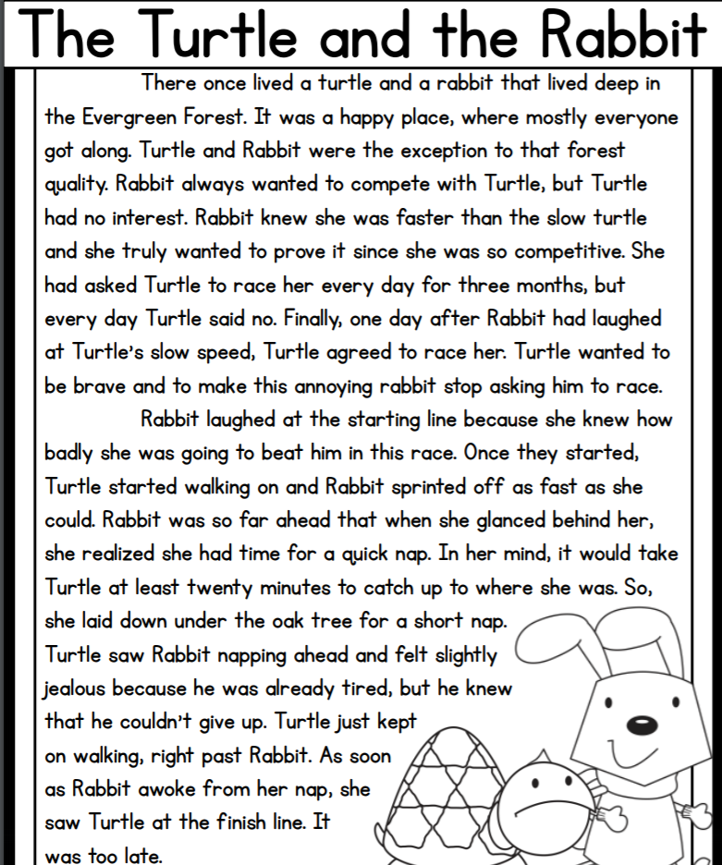
Passage 1:

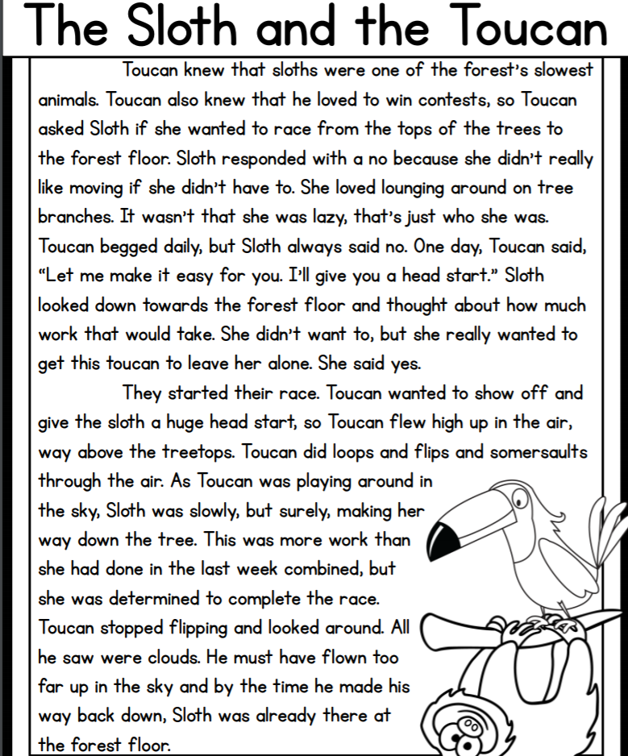
Passage 2:

Question 1: Themes - How are they the same? How are they different?

Question 2: Settings - How are they the same? How are they different?

Question 3: Plots - How are they the same? How are they different?

